# Data Model V8.3

## [Change Request 8582:](http://edappgistfsprd1:8080/tfs/ElectricDistCollection/EDAMGIS/_workitems/edit/8582)PAR22391: Add Value To Joint Pole Members Domain V8 (8.3)

Add WC (Western Communication) to Joint Pole Members domain

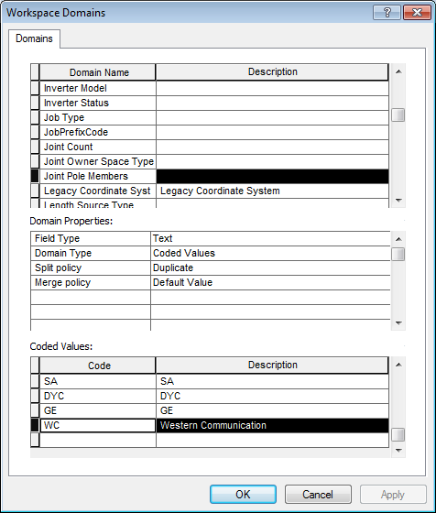

## [Change Request 10260:](http://edappgistfsprd1:8080/tfs/ElectricDistCollection/EDAMGIS/_workitems/edit/10260)Schematic_Unified_Grid added to EDGIS1P (Production) Common Features Dataset (8.3)

Already exists in EDGISG2D (came from production)

## [Issue 11571*:](http://edappgistfsprd1:8080/tfs/ElectricDistCollection/EDAMGIS/_workitems/edit/11571)DA Issue: ULS Size-coded value domain PAR 41940 (8.3)

Add 0.75 (.75”) to ULS Size-coded value domain

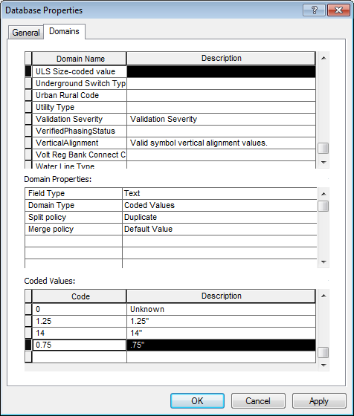

## [Change Request 11614:](http://edappgistfsprd1:8080/tfs/ElectricDistCollection/EDAMGIS/_workitems/edit/11614)Add EDGIS.SchemStreetAnno100 Anno class into EDGISA1D (8.3)

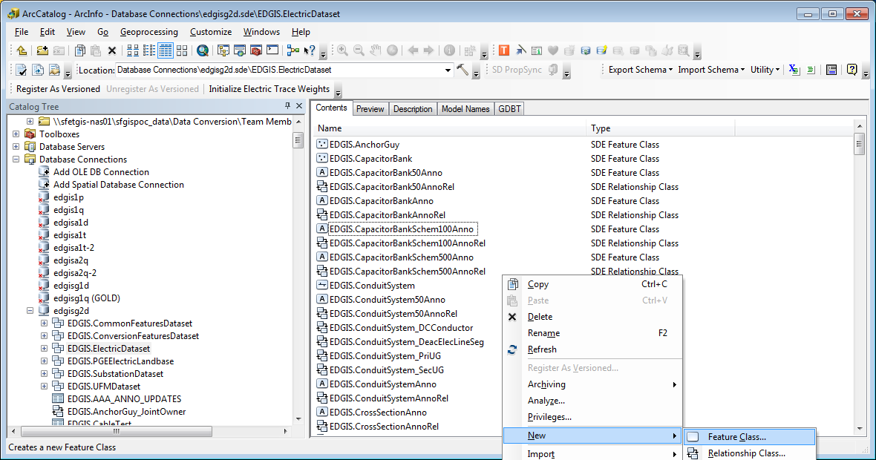

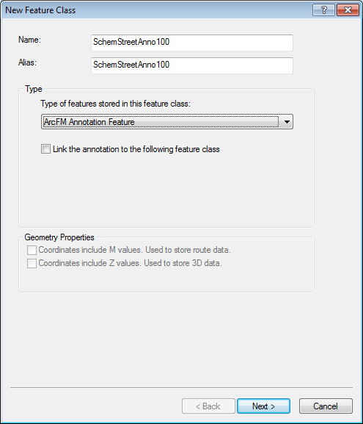

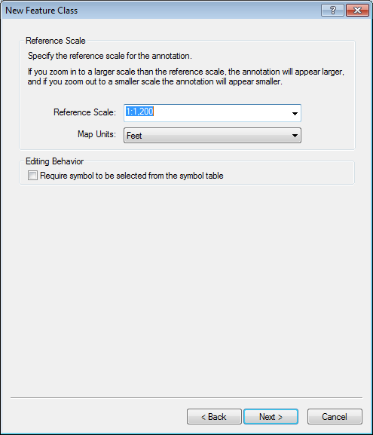

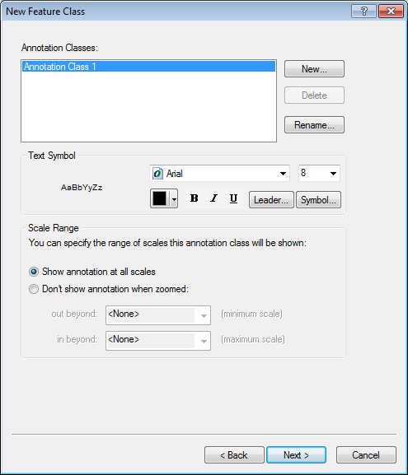

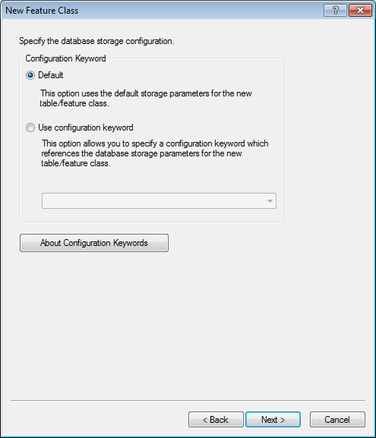

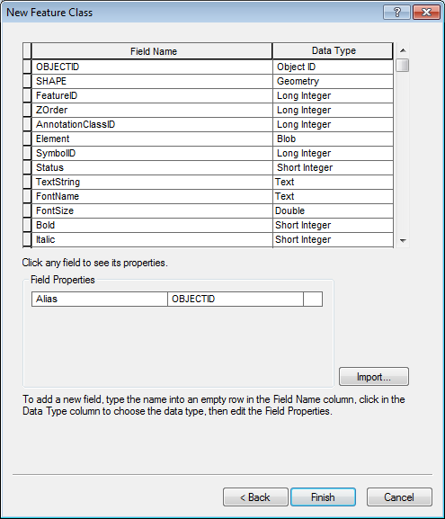

## [Change Request 11615:](http://edappgistfsprd1:8080/tfs/ElectricDistCollection/EDAMGIS/_workitems/edit/11615)Add EDGIS.SchemStreetAnno500 Anno class into EDGISA1D (8.3)

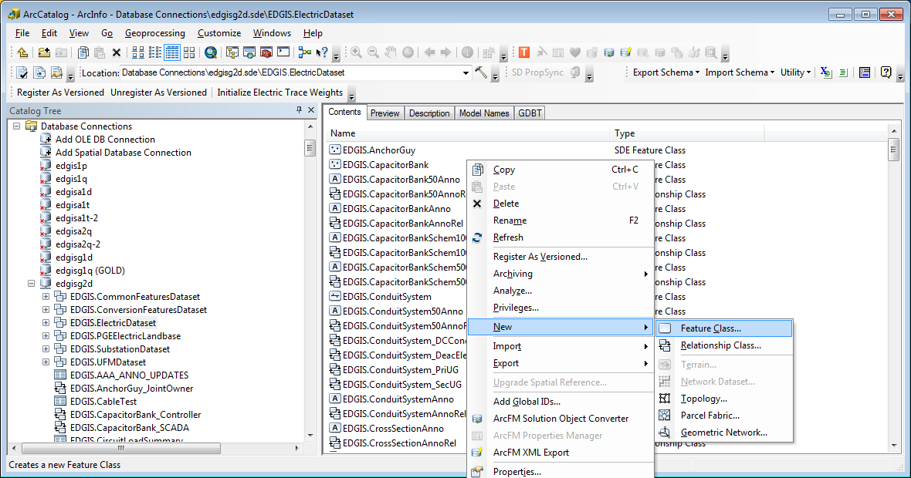

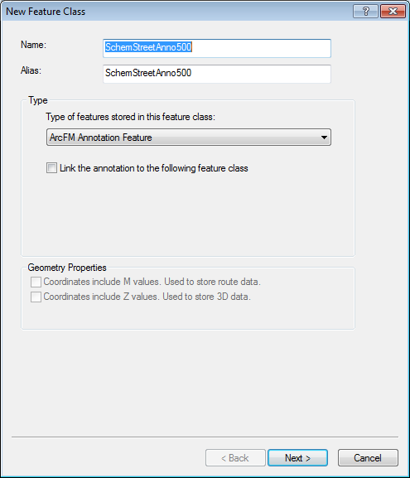

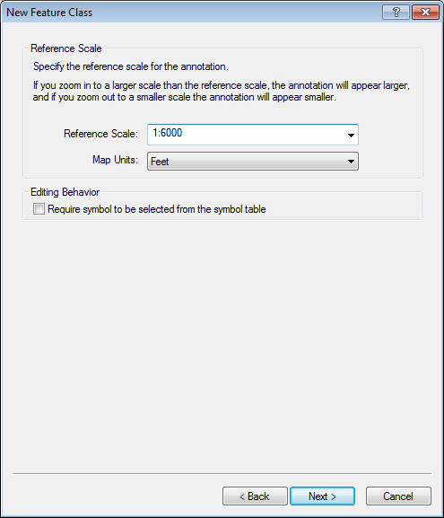

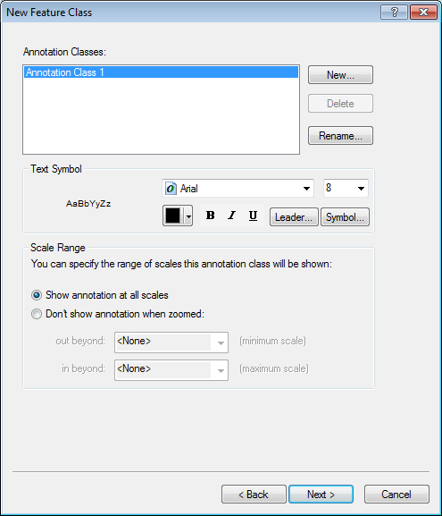

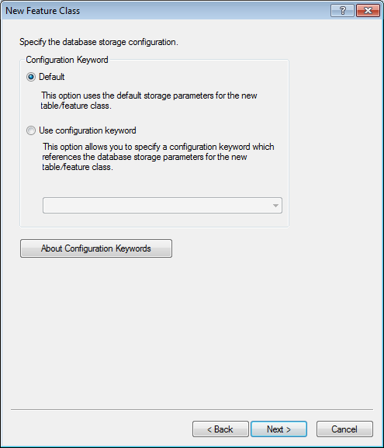

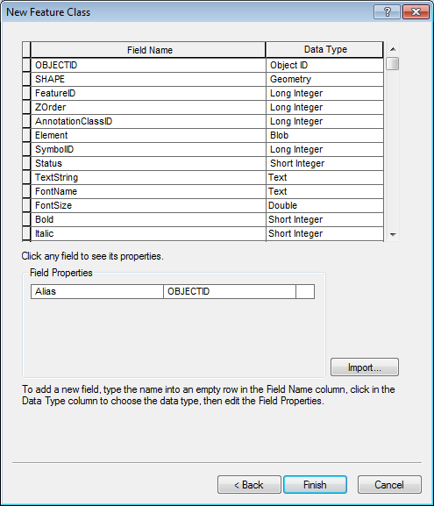

## [Issue 11669:](http://edappgistfsprd1:8080/tfs/ElectricDistCollection/EDAMGIS/_workitems/edit/11669)DA Issue: Diablo WP17 PAR 42411 (8.3)

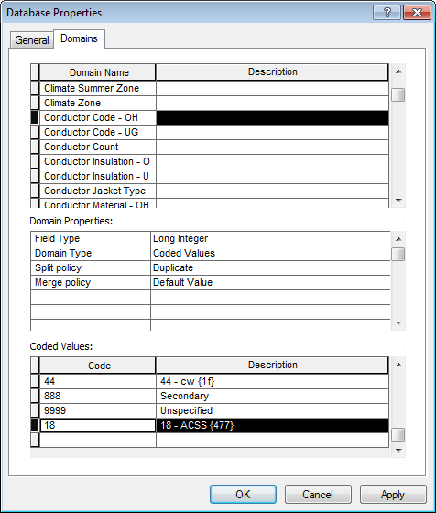

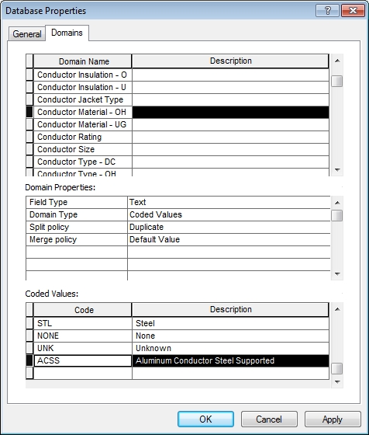

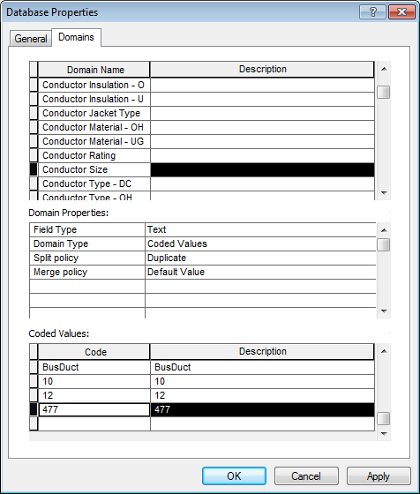

## [Issue 11670:](http://edappgistfsprd1:8080/tfs/ElectricDistCollection/EDAMGIS/_workitems/edit/11670)DA Issue: Diablo WP17 PAR 42435 – WP18_19 (8.3)

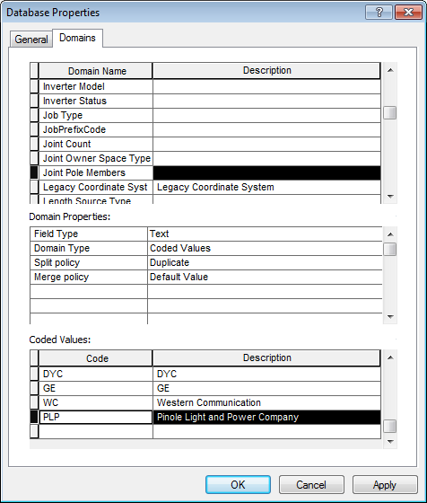

## [Change Request 11711:](http://edappgistfsprd1:8080/tfs/ElectricDistCollection/EDAMGIS/_workitems/edit/11711)Insulation - East Bay WP18_19 PAR 43230 (8.3)

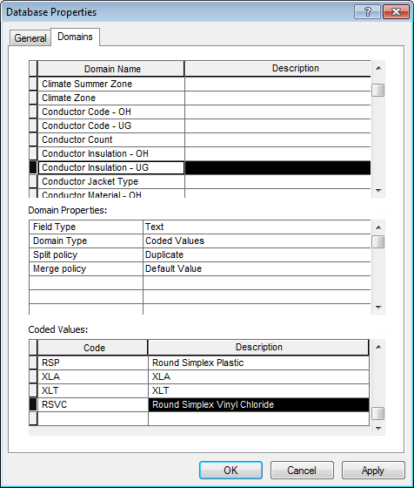

## [Issue 11913*:](http://edappgistfsprd1:8080/tfs/ElectricDistCollection/EDAMGIS/_workitems/edit/11913)New Value for Conductor Insulation - UG Domain PAR #43446 (8.3)

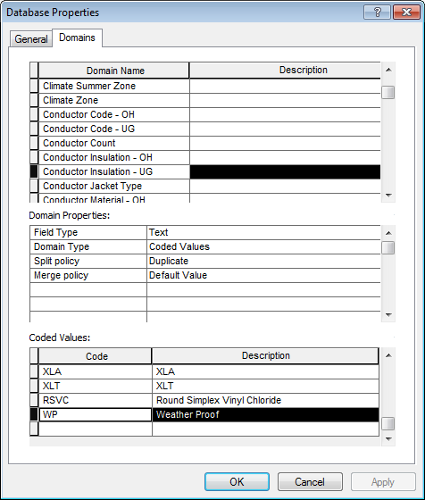

## [Change Request 12151:](http://edappgistfsprd1:8080/tfs/ElectricDistCollection/EDAMGIS/_workitems/edit/12151)Neutral conductor Annotation PAR#46279 (San Francisco) (8.3)

### EDGIS.NeutralConductorAnno

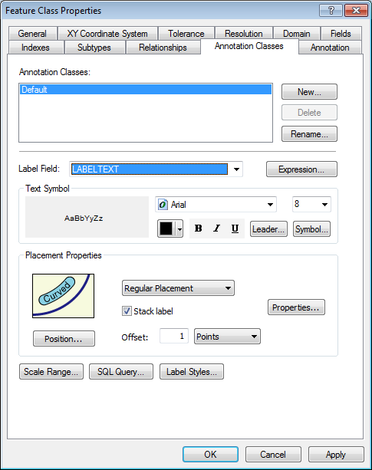

### EDGIS.NeutralConductor50Anno

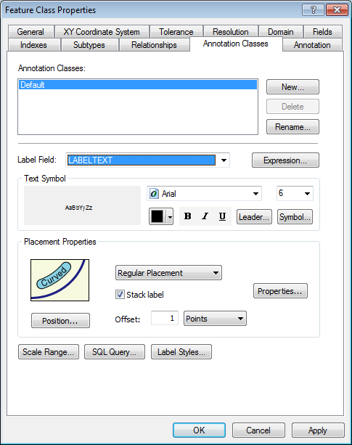

## [Change Request 12363:](http://edappgistfsprd1:8080/tfs/ElectricDistCollection/EDAMGIS/_workitems/edit/12363)RSN As New Value for Conductor Insulation - UG Domain PAR #43803 (8.3)

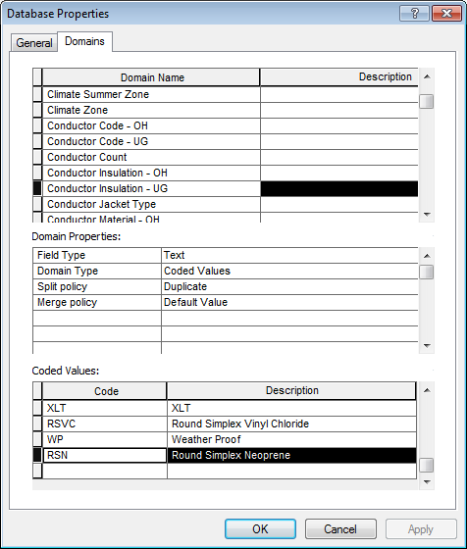

## [Change Request 12505:](http://edappgistfsprd1:8080/tfs/ElectricDistCollection/EDAMGIS/_workitems/edit/12505)Conductor Insulation - PAR 48948 (8.3)

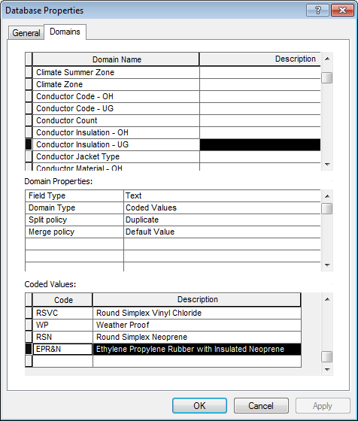

## [Change Request 12553:](http://edappgistfsprd1:8080/tfs/ElectricDistCollection/EDAMGIS/_workitems/edit/12553)Domain value PAR #49601 (8.3)

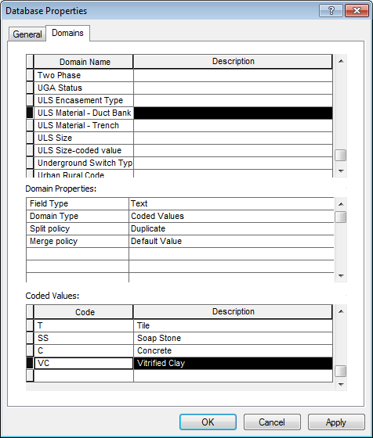

## [Change Request 12868:](http://edappgistfsprd1:8080/tfs/ElectricDistCollection/EDAMGIS/_workitems/edit/12868)PAR 46630 Santa Rosa WP22 and PAR 47244 Ukiah WP22 - Joint Pole Member domain (8.3)

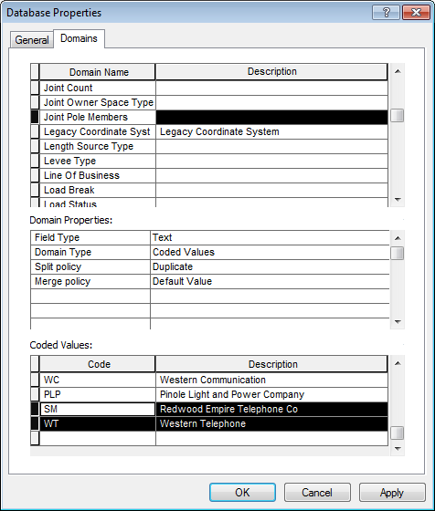

## [Change Request 12895:](http://edappgistfsprd1:8080/tfs/ElectricDistCollection/EDAMGIS/_workitems/edit/12895)County Name domain PAR 51323 (8.3)

Humbolt should be Humboldt

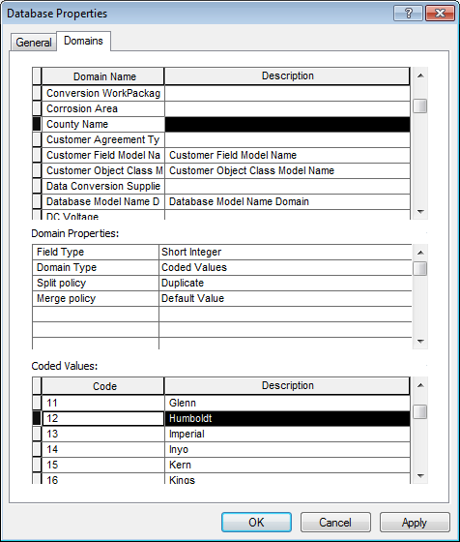

## [Change Request 12947:](http://edappgistfsprd1:8080/tfs/ElectricDistCollection/EDAMGIS/_workitems/edit/12947)New Value for Deliver Pt Customer Type Domain - PAR #49915 (8.3)

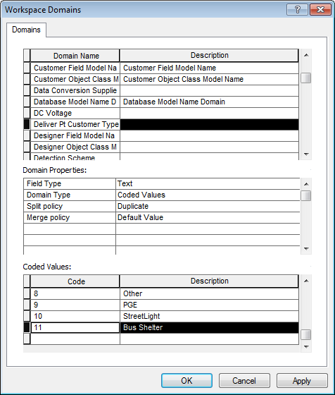

### Change EDGIS.DeliveryPointAnno and EDGIS.DeliveryPoint50Anno annotation expression as shown below

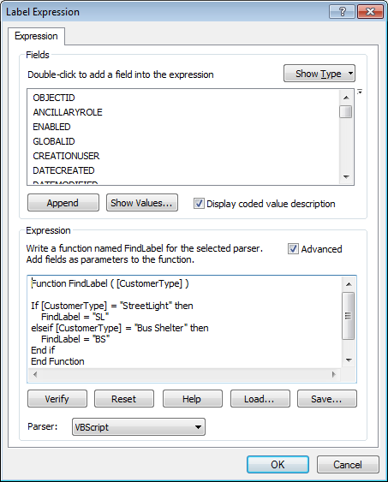

## [Change Request 12962:](http://edappgistfsprd1:8080/tfs/ElectricDistCollection/EDAMGIS/_workitems/edit/12962)New Value for Joint Pole Members Domain - PARs 49705, 49908 & 50333 (8.3)

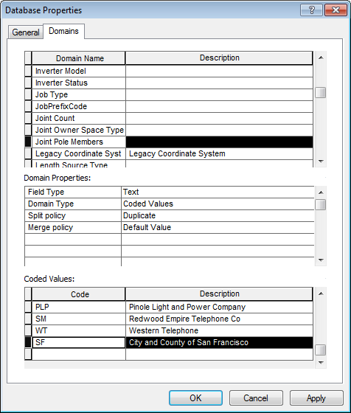

## [Change Request 13038:](http://edappgistfsprd1:8080/tfs/ElectricDistCollection/EDAMGIS/_workitems/edit/13038)New Value for Joint Pole Members Domain - PAR #51180 (8.3)

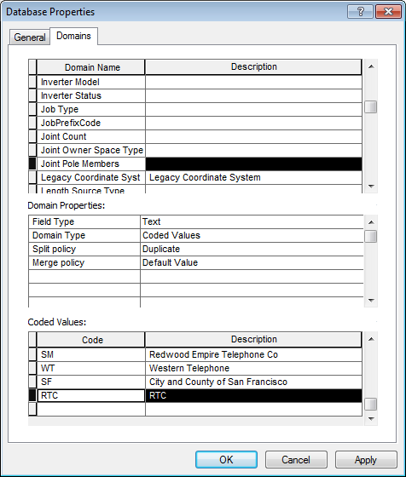

## [Change Request 13049:](http://edappgistfsprd1:8080/tfs/ElectricDistCollection/EDAMGIS/_workitems/edit/13049)New Value for ULS Material - Duct Bank Domain - PAR #48361 (8.3)

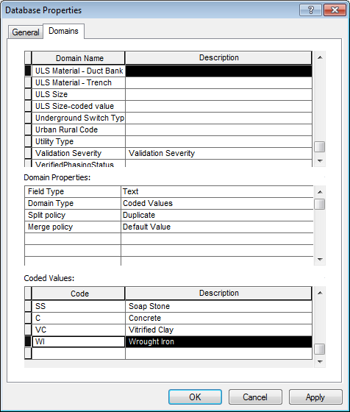

## UFM Model configuration



# Data Model V8.3 (4059)

## [Change Request 10590:](http://edappgistfsprd1:8080/tfs/ElectricDistCollection/EDAMGIS/_workitems/edit/10590)PAR 34139 - Overhead Streamline construction with underground neutral (7.X)

Add the below values to the Conductor Code – OH

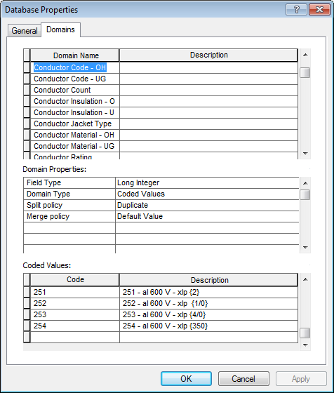

130 130 - cu {6}

131 131 - cu {4}

132 132 - cu {2}

133 133 - cu {1/0}

134 134 - cu {2/0}

135 135 - cu {3/0}

136 136 - cu {4/0}

137 137 - cu {250}

138 138 - cu {500}

201 201 - al xlp-pvc (15 kV) {2}

202 202 - al xlp-pvc (15 kV) {1/0}

203 203 - al xlp-pvc (15 kV) {4/0}

204 204 - al xlp-pvc (15 kV) {350}

205 205 - al xlp-pvc (15 kV) {700}

206 206 - al xlp-pvc (15 kV) {1000}

207 207 - al xlp-pvc (15 kV) {1250}

211 211 - al xlp-pvc (22 kV) {2}

212 212 - al xlp-pvc (22 kV) {1/0}

213 213 - al xlp-pvc (22 kV) {4/0}

214 214 - al xlp-pvc (22 kV) {350}

215 215 - al xlp-pvc (22 kV) {700}

216 216 - al xlp-pvc (22 kV) {1000}

217 217 - al xlp-pvc (22 kV) {1250}

251 251 - al 600 V - xlp {2}

252 252 - al 600 V - xlp {1/0}

253 253 - al 600 V - xlp {4/0}

254 254 - al 600 V - xlp {350}

## [Change Request 10713:](http://edappgistfsprd1:8080/tfs/ElectricDistCollection/EDAMGIS/_workitems/edit/10713)PAR 34032 Mission WP14: Add new code/desc to “JobPrefixCode” domain (7.X)

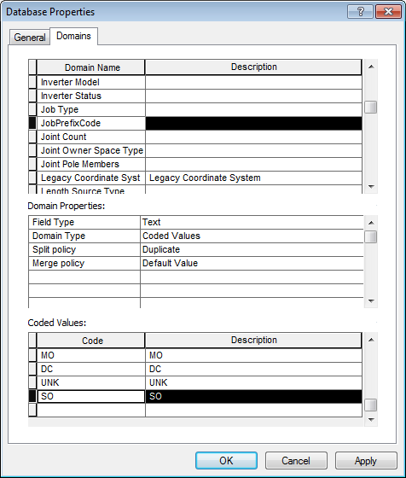

## [Change Request 10779:](http://edappgistfsprd1:8080/tfs/ElectricDistCollection/EDAMGIS/_workitems/edit/10779)PAR 33970: Add new Code/Value to Customer Agreement Type domain (7.X)

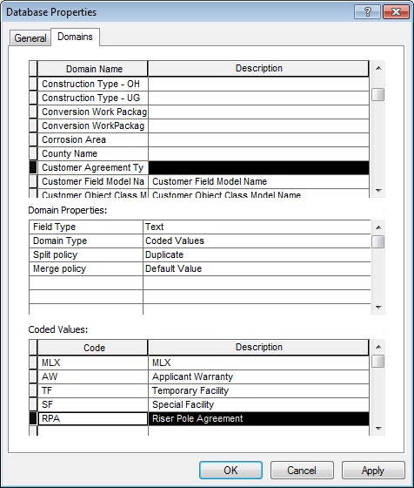

## [Change Request 10953:](http://edappgistfsprd1:8080/tfs/ElectricDistCollection/EDAMGIS/_workitems/edit/10953)PAR 36882: New code/value to Joint Pole Member domain (7.X)

## 

## [Change Request 8783:](http://edappgistfsprd1:8080/tfs/ElectricDistCollection/EDAMGIS/_workitems/edit/8783)PAR 21057: Add Values to Street Light Operating Schedule Domain V8 (7.X)

Added the below values to the “Street Light Operating Schedule” domain

|  |  |
| --- | --- |
| Code | Description |
| AN+6.5 | All Night + 6.5 Hrs |
| AN+7.0 | All Night + 7.0 Hrs |
| AN+7.5 | All Night + 7.5 Hrs |
| AN+8.0 | All Night + 8.0 Hrs |
| AN+8.5 | All Night + 8.5 Hrs |
| AN+9.0 | All Night + 9.0 Hrs |
| AN+9.5 | All Night + 9.5 Hrs |
| AN+10.0 | All Night + 10.0 Hrs |
| AN+10.5 | All Night + 10.5 Hrs |
| AN+11.0 | All Night + 11.0 Hrs |
| AN+11.5 | All Night + 11.5 Hrs |
| AN+12.0 | All Night + 12.0 Hrs |
| AN+12.5 | All Night + 12.5 Hrs |
| AN-6.5 | All Night - 6.5 Hrs |
| AN-7.0 | All Night - 7.0 Hrs |
| AN-7.5 | All Night - 7.5 Hrs |
| AN-8.0 | All Night - 8.0 Hrs |
| AN-8.5 | All Night - 8.5 Hrs |
| AN-9.0 | All Night - 9.0 Hrs |
| AN-9.5 | All Night - 9.5 Hrs |
| AN-10.0 | All Night - 10.0 Hrs |
| AN-10.5 | All Night - 10.5 Hrs |

## [Change Request 11523:](http://edappgistfsprd1:8080/tfs/ElectricDistCollection/EDAMGIS/_workitems/edit/11523)PAR 40584 Add new Code / Value to Conductor Code - OH Domain (7.X)

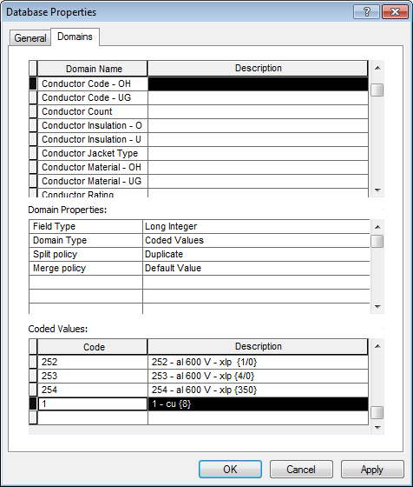

## [Change Request 12426:](http://edappgistfsprd1:8080/tfs/ElectricDistCollection/EDAMGIS/_workitems/edit/12426)Assign domain on ATTACHMENTTYPE field in Switch feature class with subtype SCADAMATESwitch (7.X)

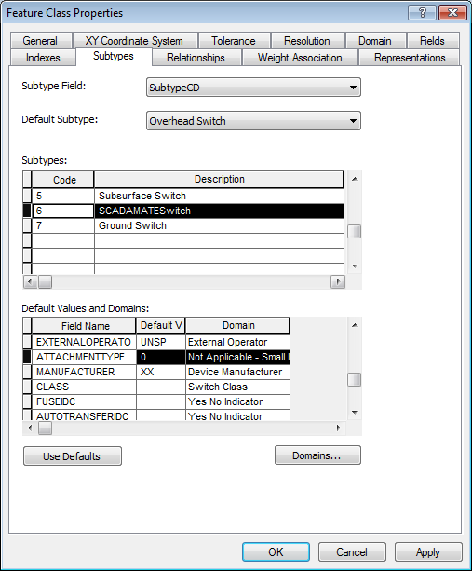

## [Change Request 12546:](http://edappgistfsprd1:8080/tfs/ElectricDistCollection/EDAMGIS/_workitems/edit/12546)Model Update for Schematics Annotation Feature Classes (8.X REQ FOR SCHEMATICS)

For all Schematics annotation, uncheck the checkbox to update On Feature Update: (see example image)

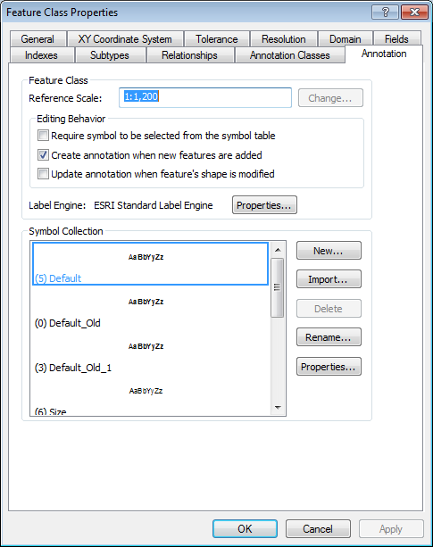

Features (anno)

-SWITCHSCHEM100ANNO  
-STEPDOWNSCHEM500ANNO  
-STEPDOWNSCHEM100ANNO  
-PRIGENERATIONSCHEM500ANNO  
-PRIGENERATIONSCHEM100ANNO  
-FUSESCHEM500ANNO  
-FUSESCHEM100ANNO  
-FAULTINDICATORSCHEM500ANNO  
-FAULTINDICATORSCHEM100ANNO  
-ELECSTITCHPOINTSCHEM500ANNO  
-ELECSTITCHPOINTSCHEM100ANNO  
-DYNPROTDEVSCHEM500ANNO  
-DYNPROTDEVSCHEM100ANNO  
-DEVICEGROUPSCHEM500ANNO  
-DEVICEGROUPSCHEM100ANNO  
-CAPACITORBANKSCHEM500ANNO  
-CAPACITORBANKSCHEM100ANNO  
-VOLTAGEREGULATORSCHEM500ANNO  
-VOLTAGEREGULATORSCHEM100ANNO  
-TRANSFORMERSCHEM500ANNO  
-TRANSFORMERSCHEM100ANNO  
-SWITCHSCHEM500ANNO

## [Change Request 13257:](http://edappgistfsprd1:8080/tfs/ElectricDistCollection/EDAMGIS/_workitems/edit/13257)Remove WAC from Conductor Insulation - OH domain

Before

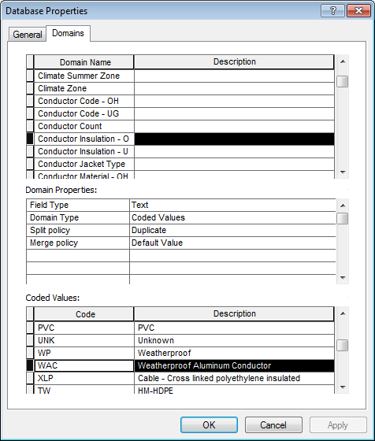

After

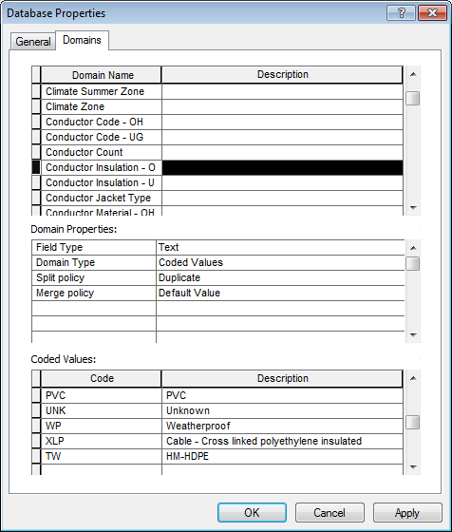

## [Change Request 13287:](http://edappgistfsprd1:8080/tfs/ElectricDistCollection/EDAMGIS/_workitems/edit/13287)Additional Values for JobPrefixCode Domain - PAR #53933

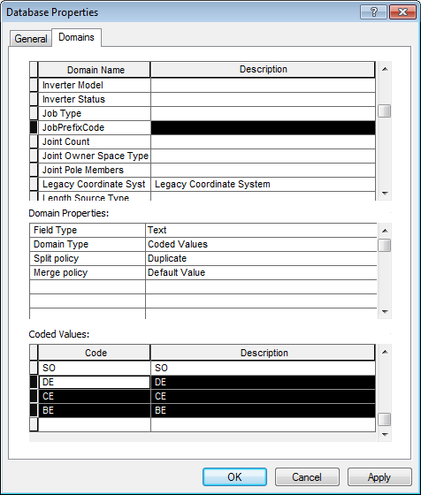

# Register as version and GLOBALID run on electric dataset

